III A Gioiosa Marea
Lingua Inglese
Prof. Margherita Sirna
Walt Disney
Walter Elias Disney was an American entrepreneur, animator, writer, voice actor and film producer. A pioneer of the American animation industry, he introduced several developments in the production of cartoons. As a film producer, Disney won 22 Oscars. Born in Chicago in 1901, Disney developed an early interest in drawing. He took art classes as a boy and got a job as a commercial illustrator at the age of 18. He moved to California in the early 1920s and set up the Disney Brothers Studio with his brother Roy. In 1928 he developed the character Mickey Mouse, his first highly popular success. As the studio grew, Disney became more adventurous, introducing synchronized sound, full-color three-strip Technicolor, feature-length cartoons and technical developments in cameras. The results, seen in features such as Snow White and the Seven Dwarfs (1937), Pinocchio, Fantasia (both 1940), Dumbo (1941), and Bambi (1942), furthered the development of animated film. New animated and live-action films followed after World War II, including the critically successful Cinderella (1950) and Mary Poppins (1964), the latter of which received five Academy Awards.
In 1955 Walt opened Disneyland in Anaheim, California. In 1965, he began development of another theme park, Disney World.
Disney was a heavy smoker throughout his life and died of lung cancer in December 1966.
Disney was a shy, self-deprecating and insecure man in private but adopted a warm and outgoing public persona. He nevertheless remains an important figure in the history of animation and in the cultural history of the United States, where he is considered a national cultural icon. His film work continues to be shown and adapted; his namesake studio and company maintains high standards in its production of popular entertainment, and the Disney amusement parks have grown in size and number to attract visitors in several countries.
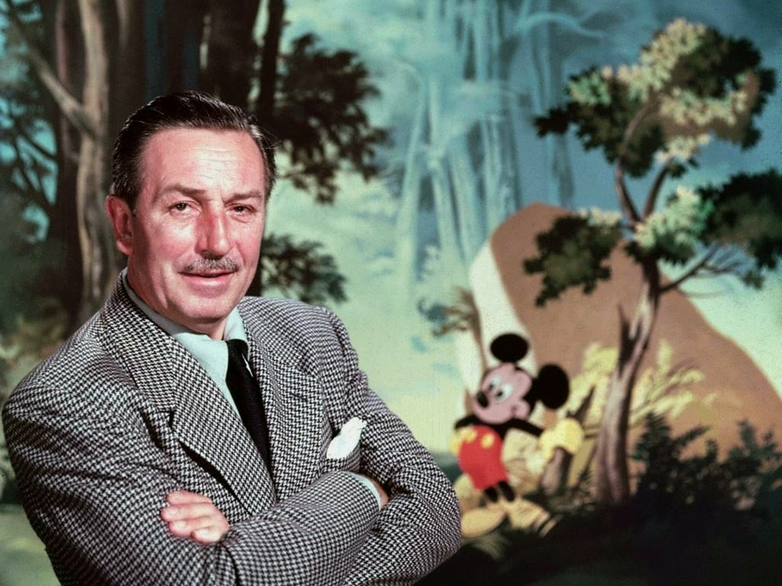

Creation of Mickey Mouse to the first Academy Awards: 1928–1933

Mickey Mouse, was possibly inspired by a pet mouse that Disney had adopted while working in his Laugh-O-Gram studio, although the origins of the character are unclear.

Walt Disney Works

In early 1950, Disney produced Cinderella. In 1950 he also produced Treasure Island, which was shot in Britain, as was The Story of Robin Hood and His Merrie Men (1952). He continued to produce full-length animated features too, including Alice in Wonderland (1951) and Peter Pan (1953).

When he visited Griffith Park in Los Angeles with his daughters, he wanted to be in a clean, unspoiled park, where both children and their parents could have fun. He visited the Tivoli Gardens in Copenhagen, Denmark, and was heavily influenced by the cleanliness and layout of the park.

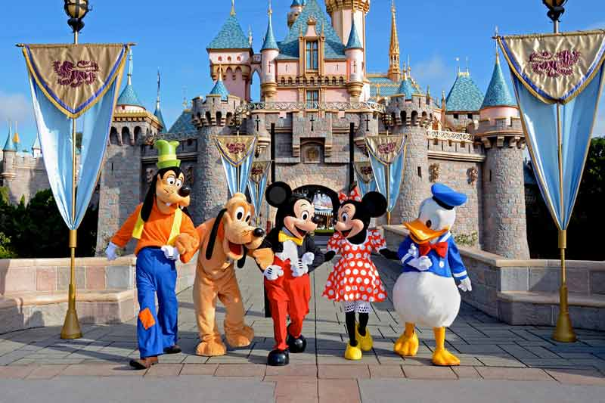

Disneyland opened in July 1955; the opening ceremony was broadcast on ABC, which reached 70 million viewers. The park was designed as a series of themed lands.

(Griffith Park, Los Angeles) 

(Giardini di Tivoli, Copenaghen)

Ciao ragazzi! Durante la videolezione di domani parleremo di Walter Disney.

Per la prossima volta, dovrete fare la traduzione e un riassunto da ripetere a me oralmente!

Have a nice day!

